Friday 26th February 2021
Dear Parents and Carers

Hello all!

I hope this newsletter finds you well. Here is our latest update.

Covid Guidance
We are currently updating our Covid guidance and we will share this next week. However, there have been incidents where parents are allowing their children from different bubbles to play on the school equipment after school. Please do not allow your child on the equipment.
Staff are also saying that there has been an increase in the number of parents/carers who are trying to engage staff in conversation at the door before and after school. Please can parents/carers not do this. Please use the year group email address or LAPS email address.

Remember we want you to come on to the school site, drop your child off and then leave again just while we are in this pandemic. Thank you for your support with this.

Brave The Shave
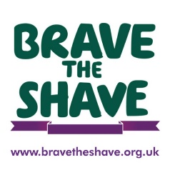

A big thank you to those parents/carers and children who have donated to my Brave The Shave page. I really do appreciate it. Just a reminder that it is a charity event where people can raise money for MacMillan Cancer Support by shaving their heads. I am taking part on March 5th! If any parent/carers would like to make a donation, you can go the the Brave the Shave website and search my name, Deamonn Hewett-Dale, and make a donation or use this link https://bravetheshave.macmillan.org.uk/Shavers/deamonn-hewettdale/ . We will be recording the event and sharing it on the school website.

Love Has No Labels
The ‘Love Has No Labels’ work the children have completed this week has been incredibly successful. Look out for the video on the website and watch the Friday Assembly to see lots of examples of what we have been up to.

World Book Day
On Thursday 4th March, we will be celebrating World Book Day both in school and through our online learning. As a school we have created a series of activities which will be posted on seesaw/tapestry with the children having a choice of which activities to complete. The number of activities will be set by the year group. The activities have been created so that all children can access in their own way and also, so that families can get involved and work on the activities together. One of the activities involves using potatoes to create their favourite book characters, so fun for everyone to get involved with and post on seesaw/tapestry.

There is a book which we will be being shared on the day called ‘Leon and the Place Between’. Mr Shaw will be reading it to the children and then this can be used for the various activities or the children can choose from their own favourite characters.

We are NOT asking children to dress up this year although it is one of the activities should they wish too. Children in school need to wear school uniform.

Unfortunately, due to the current lockdown situation we have not been able to acquire the World Book Day books we usually provide. We are awaiting responses from numerous sellers so we will let you know if we will be able to provide these in the future.

Finally, we will be holding a Masked Reader event starting on the 1st March. Each day two masked readers will be loaded to seesaw for the children to guess who is behind the mask from our range of teaching staff. Readers will be revealed on Monday 8th March as the children return to school.

Parent Governor
We are looking for people who are interested in becoming a Parent Governor for The Flying Bull Academy. If you would like more information or a conversation about the role, please let me know and I will get in touch with you.

As usual if you have any questions or any more positive comments, please contact me on head@fbacademy.co.uk

Kind regards
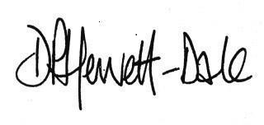
Mr D. P. Hewett-Dale,
Headteacher

