Friday 26th March 2021
Dear Parents/Carers
Welcome to another Friday!

Next week is the last week of the Spring Term. Please remember that Thursday 1st April is the last day of term. The Easter Holiday starts on Friday 3rd April – Good Friday.

Update on guidance

If anyone in your household is showing symptoms of Covid 19, children SHOULD NOT come in to school until that person with symptoms has had a negative test result.

Any adult that comes on site must be wearing a mask unless they have an exemption lanyard. We have asked that if you can, and if your child is old enough, you leave your child at the Malins Road gate in the morning and pick them up from outside the Steerforth Close gate at the end of school. If you are exempt and you come on site without a mask, please ensure that you are sticking to the social distancing rules.

Love has no labels: race equality

We’ve loved seeing children and staff embrace the message of the national Show Racism the Red Card campaign and celebrating the fact that “together we are beautiful”. We will be submitting some of their work for a nation-wide competition in the summer term: keep an eye on the website for photos and updates over the coming weeks!

Love has no labels: disability awareness

Our Love Has No Labels theme continues after Easter with a focus on disability awareness and inclusion. Watch this space!

TikTok

There have been some issues with children talking about TikTok, especially some of the new trends on there which has hit national news. I would rather not talk about the current one as I feel children will go looking for it. I also need to remind you that children need to be 13 years of age to use TikTok.

Parent Governor

We have only had one expression of interest in the role of Parent Governor. Please email me if you would like more information.

As usual if you have any questions, please contact me on head@fbacademy.co.uk

Kind regards
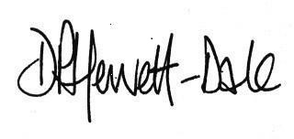
Mr D. P. Hewett-Dale,
Headteacher

