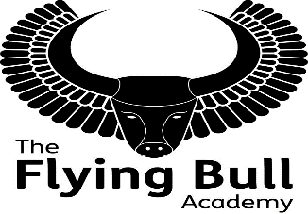 The Flying Bull Academy

TEACHING ASSISTANT (Fixed Term)
Part Time Hours - Term Time Only
Salary: Trust Band 2, £18,065 - £18,795 per annum,
Actual Salary: £11,534 - £12,000
Located in the heart of Portsmouth, The Flying Bull Academy is proud of its caring ethos, encouraging and supporting children to achieve their full potential. The academy is a positive and active place to work and we are looking to appoint a Teaching Assistant to join our successful team of support staff. We believe that success here is built on strong relationships between everyone involved in the academy.
As a Teaching Assistant you would be expected to contribute to the pupil’s development including their physical and mental well-being in supporting the teaching and learning in the class room, providing general and specific assistance to pupils, under the direction and guidance of the Class teacher, Phase Leader and/or the Special Educational Needs and Disabilities Co-ordinator. This will involve providing assistance to the Class teacher in supporting pupils on a one-to-one or small group basis, across a wide range of activities and supported learning activities, including the preparation and maintenance of resources. You will need to be able to deal with challenging behaviour with a firm but fair approach. You will be willing to support pupils with medical and personal hygiene needs. Being ELSA qualified would be an advantage in supporting our pupils however it is not essential.
With experience of working with children, ideally in a primary age setting, you will have excellent interpersonal skills that enable you to communicate with a wide range of people, including pupils, their parent/carers and the teaching staff. You will be resilient and hard working with the ability to work on your own initiative while understanding the need to work as part of a cohesive team.
In return, you will be part of the University of Chichester Academy Trust, bringing you added benefits and opportunities. You will find that each of our Academies has a unique identity, but a shared belief in creating a positive and enriching environment, where all staff feel valued.
Visits to the school are strongly encouraged and welcomed; please ring the school office to arrange an appointment (02392 694313).
You can apply for this vacancy by downloading the University of Chichester Academy Trust application form (www.unicat.org.uk/careers) and supporting documents and sending it to the school by e-mail (cnaughton@fbacademy.co.uk) or post.
Closing date: Wednesday 22nd September 2021 Interview: 28th September 2021

